<https://kvhra.shrm.org/> SHRM Chapter #: 694 P.O. Box 1445, Waterville, ME 04903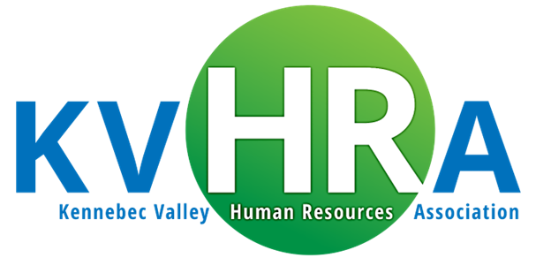

***2025 Programs/Meeting Information***

*(Topics & speakers are subject to change. Please review the registration communications carefully in the event there are meeting changes)*

|  |  |  |  |  |  |
| --- | --- | --- | --- | --- | --- |
| Morning Agenda  7:30 a.m. – 7:50 a.m. – Registration & Networking (Breakfast if in-person meeting)  7:50 a.m. – 8:00 a.m. - Sponsor Presentation  8:00 a.m. – 9:15 a.m. – Speaker Presentation and Q&A  9:15 a.m. – 9:30 a.m. - Chapter business meeting | **Date** | **Location** | **Topic** | **Speaker(s)** | **Sponsor** |
| 1/08/2025 | Best Western  Waterville | **Employment Law News** | **Peter Lowe, Partner**  Brann & Isaacson | **Nimble Group**  (Conf Pass Drawing) |
| 02/12/2025 | Calumet Club  Augusta | **Ladder of Inference** | **Danielle Fox**  Director – ME Legislature, Policy & Legal Analysis | TBD |
| 03/12/2025 | Best Western  Waterville |  |  |  |
| 04/09/2025 | Best Western  Waterville |  |  |  |
| MAY 2025 | Samoset  Rockland ME | **30th Annual**  **Maine HR Convention** |  | **Nimble Group** |
| 06/11/2025 | Calumet Club  Augusta |  |  |  |
| 09/10/2025 | Calumet Club  Augusta |  |  |  |
| 10/8/2025 | Best Western  Waterville |  |  |  |
| 11/12/2025 | Calumet Club  Augusta |  |  |  |
| 12/10/2025 | Best Western  Waterville |  |  |  |

Rev. 12/17/25 *Meetings generally held the 2nd Wednesday of the month, no meetings in July & August.*